Paint

**“B”**

**-Draw in color**

**-Declare, Fill, Work with, Save and Retrieve Arrays (.dat files)**

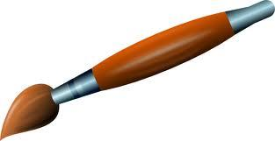

**“A”**

**-Color Picker**

**-3 horizontal scrollbars**

**-Save and retrieve in color**

**-Fix drawlines**

**-Scrollbar for line size**

**-Draw Shapes**

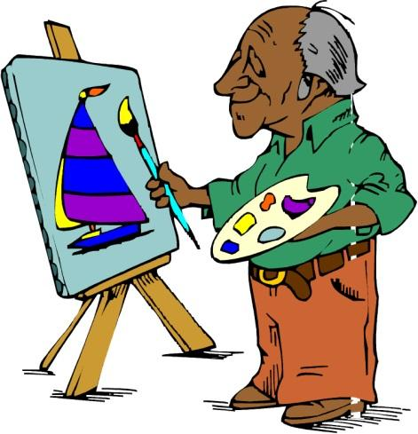

Menus: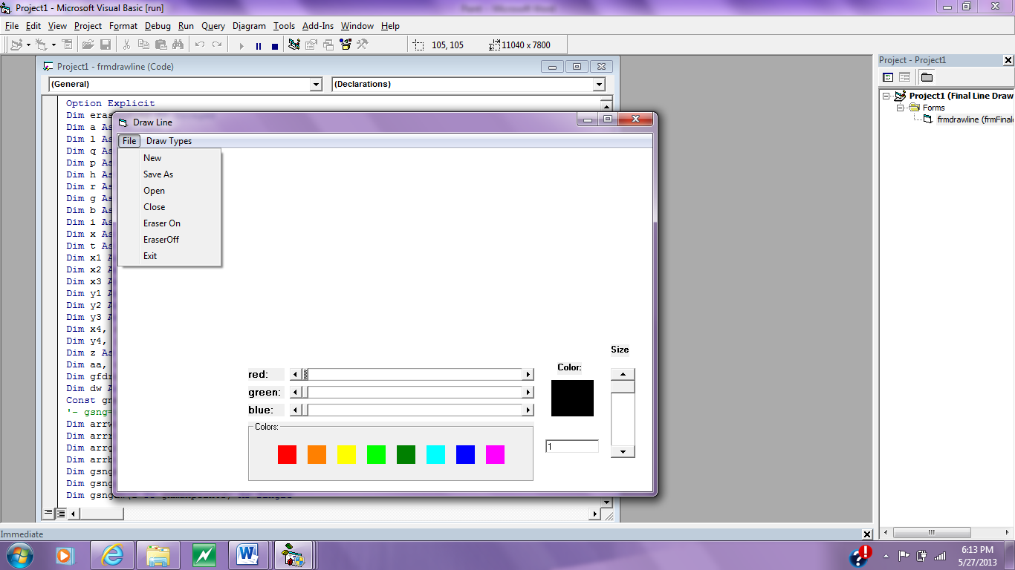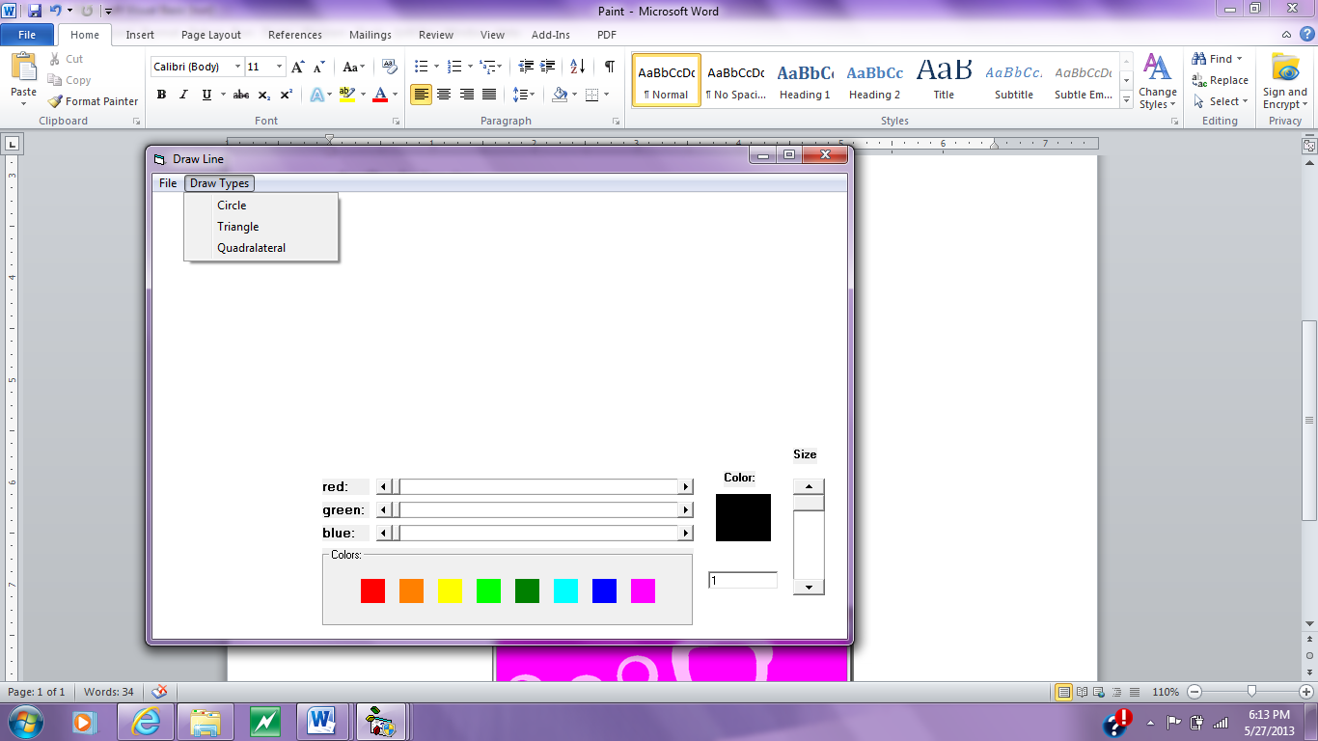

Full Form: 